Parties to the Nauru Agreement

FIMS Inc

Application Form

31 July 2019

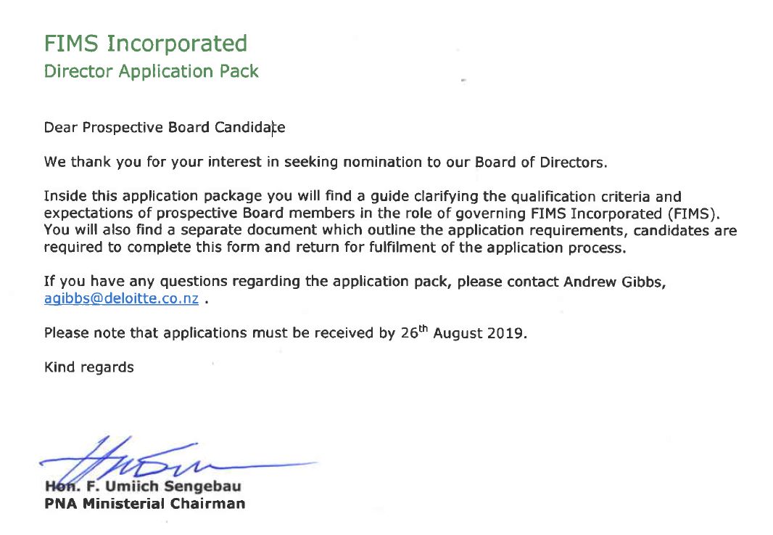

FIMS Incorporated
Director Application Pack
Process Guide

Background
The Parties to the Nauru Agreement (PNA) controls the world’s largest sustainable tuna purse seine fishery.
The PNA members include the Federated States of Micronesia, Kiribati, Republic of Marshall Islands, Nauru, Palau, Papua New Guinea, Solomon Islands, Tuvalu. Tokelau participates in the PNA Vessel Day Schemes (VDSs) and the Federated States of Micronesia Arrangement (FSMA) for regional access.
The PNA are considered global leaders in tuna conservation and management, many PNA conservation measures are world firsts including amongst others;

- Purse seine and Longline Vessel Day Schemes,
- Joint domestic Vessel Licensing Arrangement (FSMA),
- High seas closures to fishing,
- Controls on fish aggregating devices (FADs),
- In port transhipment of purse seiners,
- Catch log books, and e reporting,
- FIMS platform,
- Protection for whale sharks, sharks and turtles, and
- The 100% coverage of purse seine fishing vessels with satellite tracking (VMS) and observers.

For further information please see the. https://www.pnatuna.com/

Integral to PNA’s success is iFIMS, a fully web-based integrated fisheries information management system developed to be “Fit for Purpose”. This system has the capabilities including amongst others;

- Highly secured web interface,
- Online vessel registration,
- Monitoring vessels and licensing,
- management of the vessel day scheme,
- E reporting,
- Asset tracking systems, and
- Observer management.

For further information please see the https://www.ifims.com/

iFIMS is registered in the Republic of Marshall Islands (RMI) and is currently owned by a private individual.

FIMS Incorporated
The next step for PNA plus Tokelau is the acquisition of iFIMS. FIMS Incorporated (FIMS) will be established by the Parties as the vehicle to see out this acquisition, it will sit as an independent commercial entity from PNA with a clear vision and purpose and will provide a range of services to PNA member fisheries and other sovereign states.
To ensure FIMS is adequately governed and supported to operate, a skills-based sitting board will be appointed made up of 5 members, by the PNA plus Tokelau owners.
To further define a skills-based sitting board – board members will have the requisite skills and experience to achieve strategic and operational success, they will be actively involved in ensuring beneficial decisions and actions are made and where required will provide comprehensive recommendations to ensure shareholder expectations are met.

Position Descriptions
For the purposes of FIMS the required board will represent an appropriate mix of skills and experience to benefit and support the company’s operating and strategic direction. Broadly five representative positions have been identified who will hold the relevant expertise, skill-sets and experience to form a strong and effective Board, meeting the company’s needs.
Candidates are required to outline their skills and experience against our skills matrix which include –
- Operations / Political - has a high understanding of commercial operations in the Pacific in particular PNA and has the ability to broker relationships,
- Fisheries / Sector - has a high understanding of the Fisheries sector in particular in the Pacific,
- Information Technologies - has a high level of skills and understanding regarding technology design, development and operation,
- Financial / Accounting - has a high level of skills and understanding regarding financial, operational and management reporting and decision-making.
- Legal - has a high level of skills and understanding regarding legal and operating requirement in particular in the Pacific and with Sovereign Nations.

All candidates are required to have previous governance experience.
One of whom shall be appointed chairman by the shareholding meeting.

Skills Matrix
Included in the application requirements form is a skills matrix developed specifically for the FIMS board. The matrix outlines the core competencies sought from individual directors including those which are particular to each position.
All candidates are required to self-assess their capabilities across all competencies, an election is made from a competent (1) to specialist ability (4). This will be used in the evaluation process alongside the candidate’s curriculum vitae (cv) and covering letter explaining their reasons of suitability for the position.

Period of Appointment
Between 3-5 years, for the first appointment period, 3 years for subsequent periods. The Board reappointments will be staggered for the first 5 Directors appointed, to ensure governance continuity and the rotation policy will be agreed by the Board Chair, on a random selection process, during the first year. Subject to performance an incumbent Directors can be nominated for re-election for another for 3 year term.

Time Commitments / Expectations
Quarterly meetings. That said during establishment of one year 2 extra meetings may will probably be required, this will be determined by the Chair). Meetings will be face to face in the PNA region unless otherwise agreed by the Chair.

Remuneration
The following fees are proposed for the respective
Type of Fees | Position | Fee Proposed US$
Sitting fees per day | Chair  Deputy Chair  Director | $2,000  $1,500  $1,000
Stipend per year | Chair  Deputy Chair  Director | $8,000  $6,000  $4,000
Travel time per day | Chair  Deputy Chair  Director | $1000  $750  $ 500
Expenses | Chair, Deputy Chair, Director | Most direct Business Class Travel,  Standard Accommodation, and board approved expenses,

Evaluation Process
The evaluation process will be initiated by a due diligence exercise, this includes reviewing your cv, consulting referees, executing jurisdictional checks to ensure eligibility and ensuring no conflicts of interest exist preventing the candidate from appointment.
An evaluation of all appropriate submissions will then take place. The level of experience, suitability to the position including skills and strategic leadership offered and the self-assessed skills-matrix provided is considered.
A short-list will then be formed, the successful candidates will then be approached for an interview. Interviews will take place via a conference call and the structure of such interviews will be provided to candidates in advance, the timetable as outlined below.
Following the interview recommendations will be made to the PNA plus Tokelau Ministers of the preferred candidates for the FIMS Board at their September meeting

Key Contact
Deloitte Limited (as trustee for the Deloitte Trading Trust) will be the centre point of contact regarding the application process. Deloitte will ensure the process is fair and consistent for all candidates and is available for any questions you may have, via email.
Attn: Andrew Gibbs, Partner, Deloitte
Re: FIMS Incorporated Director Applications
agibbs@deloitte.co.nz

Key Dates

 | Deliverable | Due Date
1 | Guidance on the process finalised and delivered to Ministers | 31 July
2 | Nominations for Board positions opens | 1 Aug
3 | Candidates to due own due diligence and apply | 1 to 26 Aug
4 | Candidates to express interest by close date | 26 Aug
5 | Deloitte undertake evaluation of all applicants against criteria and provide a short listing of recommendation for review and confirmation by Officials | 30 Aug
6 | Reference checks complete on shortlist complete | 3 Sept
7 | Draft Nomination Paper sent for Review by Officials | 4 Sept
8 | Final Nomination Paper sent to Ministers | Week 9 Sept
9 | Board members notified and notice of board meeting issued | Week 18 Sept
10 | Candidates notified of travel arrangements | Week 20 Sept
11 | First FIMS Inc Board meeting and induction | Week 7 Oct

FIMS Incorporated
Director Application Pack
Application Requirements

Personal details
Name
Birth Date |  | Gender
Email
Address
Nationality

Eligibility (please circle the correct response)
I am eligible for a Directorship position in the PNA Region | Yes | No
I am not aware of any conflicts of interest or other matter preventing the appointment of a Directorship position in FIMS Incorporated | Yes | No
If no, please specify conflicts of interest or other matter for consideration

Supporting Documentation
I have attached a current curriculum vitae, with 2 referee letters and contact details | Yes | No
I have attached a covering letter explaining suitability to positions, why you have applied and what unique skills and experience you will bring to the governance of the FIMS Inc. | Yes | No
I have completed and attached the skills-matrix in Appendix A | Yes | No

Declaration
I confirm that the statements on the form and support for the application attached are true and correct.
Signed |  | Dated

Please fill out the relevant sections, attach the required supporting documentation and email your form and documents to agibbs@deloitte.co.nz
